**Gym Equipment for playing field from the latest grant**

A successful grant for £4000 was won from NNC this was earmarked for gym equipment for the playing field.

I propose we take the fresh air quote for 2 pieces of equipment and that they are sited on the area of ground between the pathway and the deeps in the area that the trees were planted (see photo).

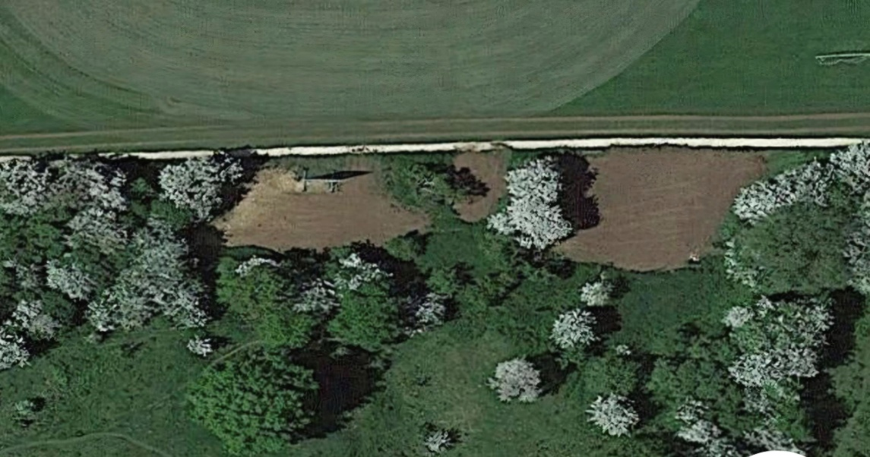



The 2 pieces are

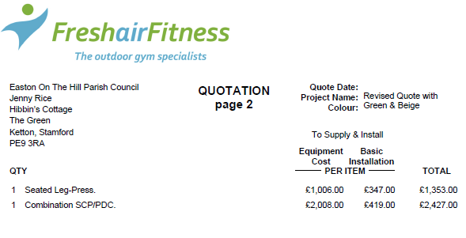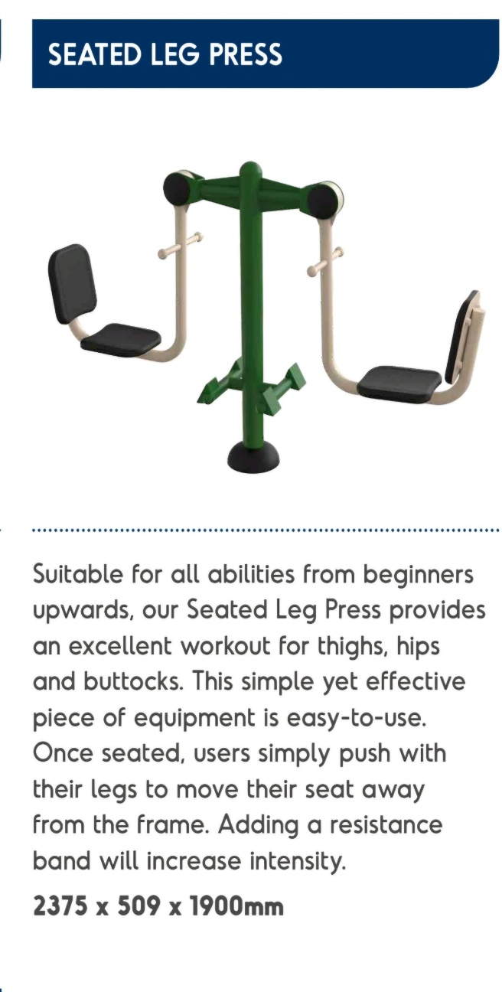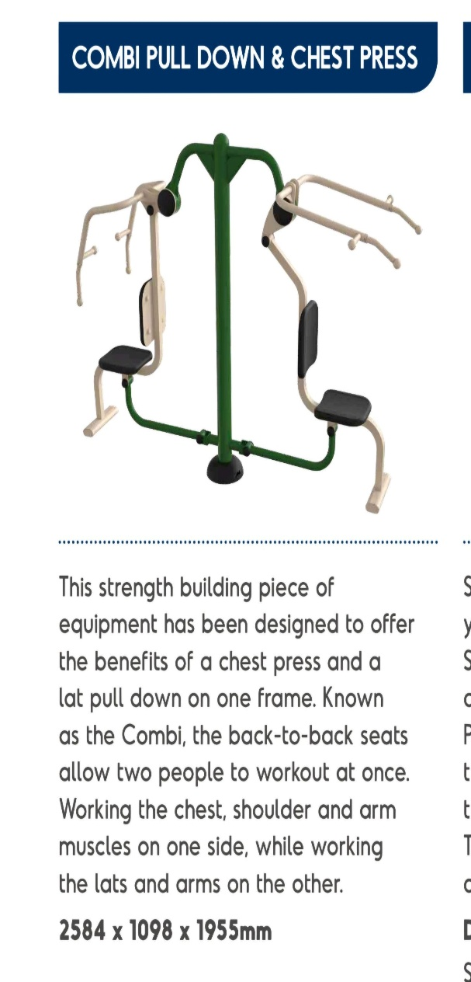

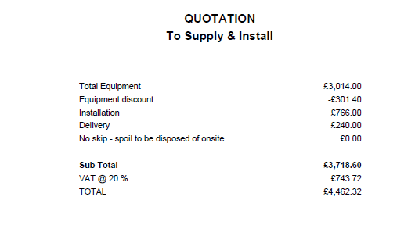

I would see if they could supply some extra rubber matting that could go under the arch climber as this was highlighted in rospa report for the last few years.

Other quotes received as follows;

**Fresh Air Fitness** [**www.freshairfitness.co.uk**](http://www.freshairfitness.co.uk)

**For 3 pieces**

Leg lift station

Seated leg press

The Rider

Total £3992

**Wicksteed** for one piece – Chest press and pull down combo as above is 4k alone.